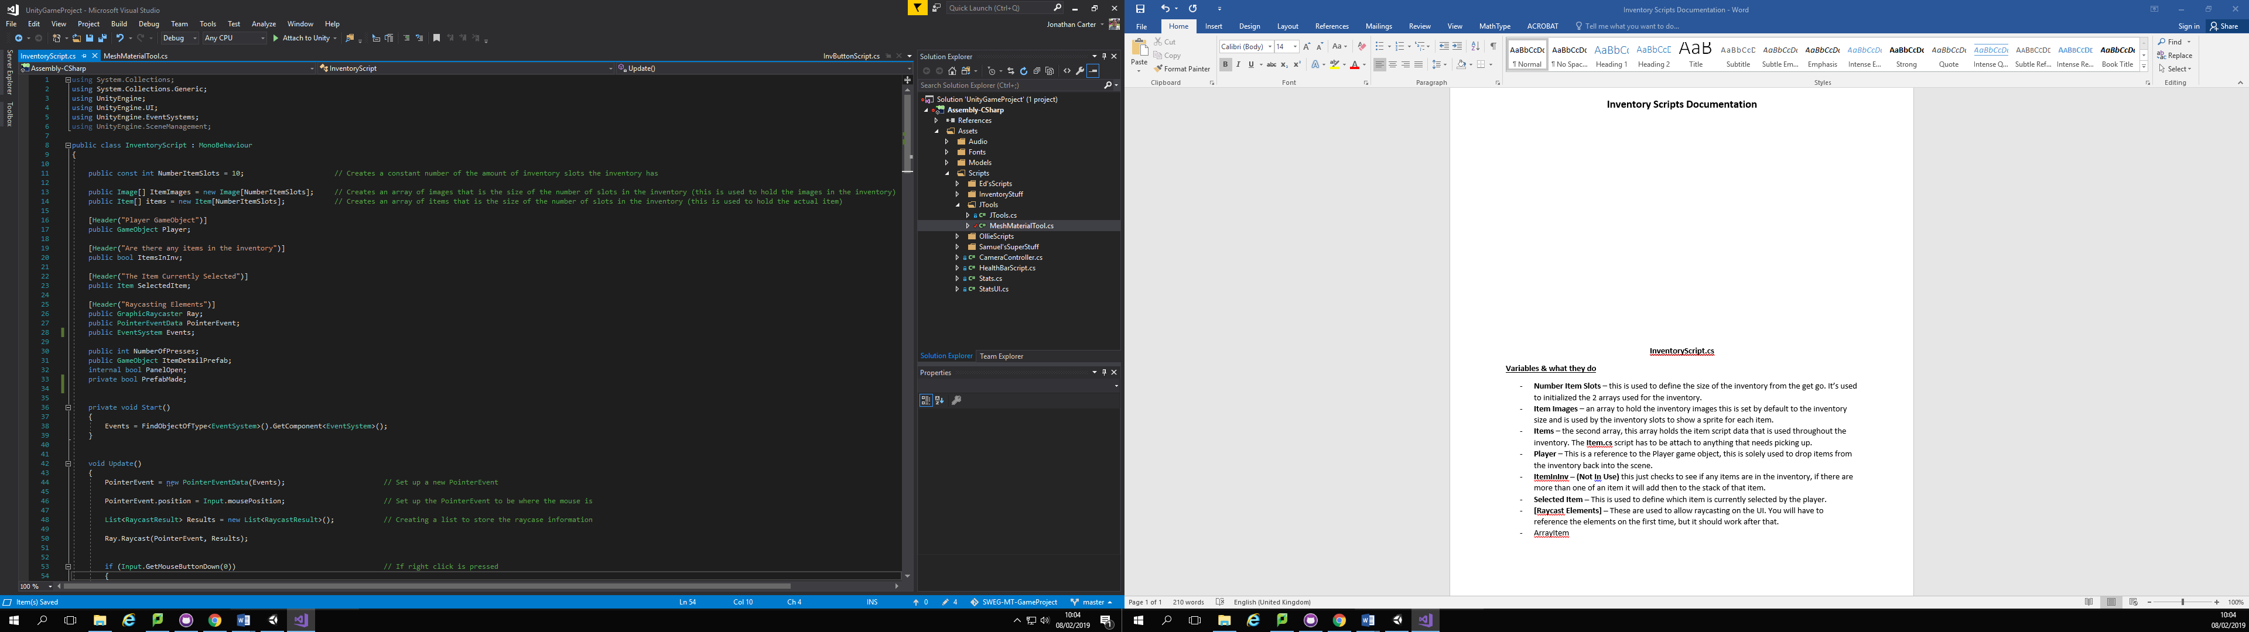**Inventory Scripts Documentation**

**InventoryScript.cs**

**Variables & what they do**

* **Number Item Slots** – this is used to define the size of the inventory from the get go. It’s used to initialized the 2 arrays used for the inventory.
* **Item Images** – an array to hold the inventory images this is set by default to the inventory size and is used by the inventory slots to show a sprite for each item.
* **Items** – the second array, this array holds the item script data that is used throughout the inventory. The **Item.cs** script has to be attach to anything that needs picking up.
* **Player** – This is a reference to the Player game object, this is solely used to drop items from the inventory back into the scene.
* **ItemInInv – (Not In Use)** this just checks to see if any items are in the inventory, if there are more than one of an item it will add then to the stack of that item.
* **Selected Item –** This is used to define which item is currently selected by the player.
* **[Raycast Elements] –** These are used to allow raycasting on the UI. You will have to reference the elements on the first time, but it should work after that.
* **Number of Presses –** this is used for the popup UI, it counts the number of times an item is pressed and opens the UI popup if it is pressed 2 times.
* I**tem Detail Prefab –** This needs assigning to have the prefab (currently called UIBG). So it can open the UI when an item is pressed twice in a row.
* **Panel Open –** This is used to check if the UIBG prefab has been opened already.
* **Prefab Made –** Checks if theUIBG prefab is already in the scene or not.

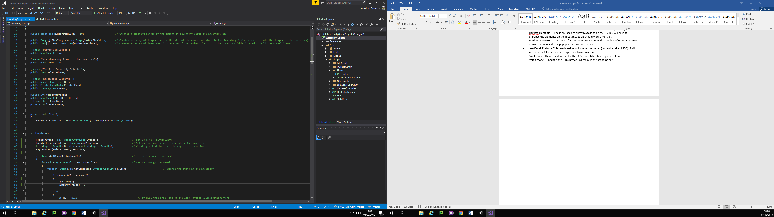**Start Function**

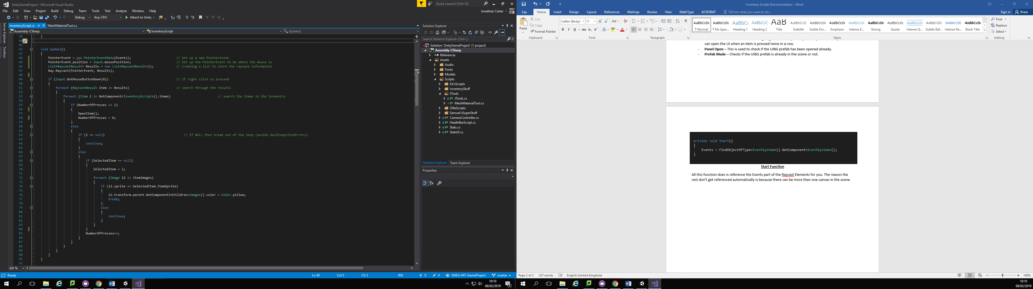All this function does is reference the Events part of the Raycast Elements for you. The reason the rest don’t get referenced automatically is because there can be more than one canvas in the scene.

**Update Function**

The first 4 lines of this function manage the raycasting of the player’s mouse on the UI. Then the function checks to see if the left mouse button has been presses, searches all raycast results & searches to see if any of the raycasted items are items stored in the inventory script. Then the function checks to see if the item has been pressed twice, it’ll call the **Open Item** function and reset the number of presses. If the item wasn’t pressed twice it’ll null check to make sure there is an item, if the is an item it’ll set the selected item to the pressed item and set the colour of the selected item image to yellow so it gives visual feedback that it has been selected, it also increments the number of presses at the same time.

*ToDo*

*Add Item Function*

*Remove Item Function*

*Open Item Function*

*Clear Inv Function*

*Set Item Sprite Function*